**MENU DATABASE**

**Database name: shop_db**

**Table name: cart**

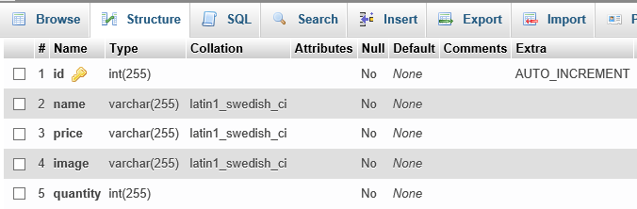

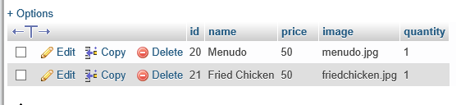

**Table 2 name: products**

